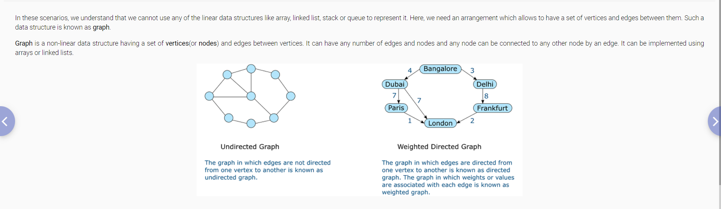

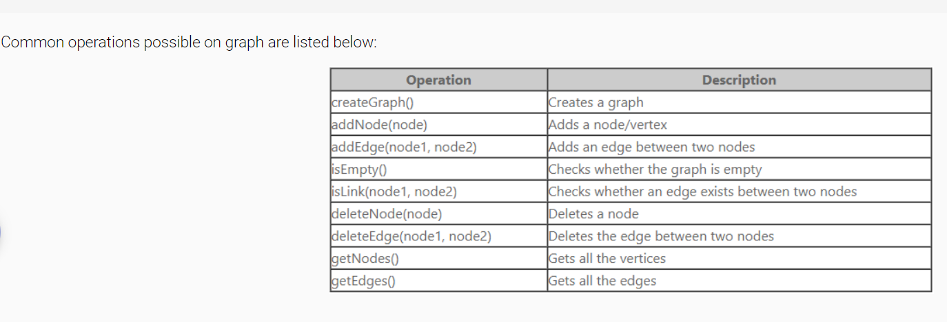

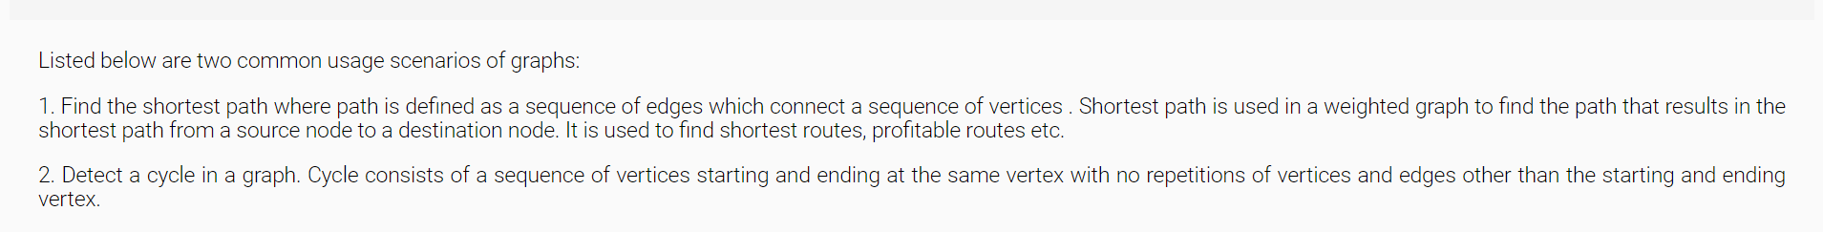

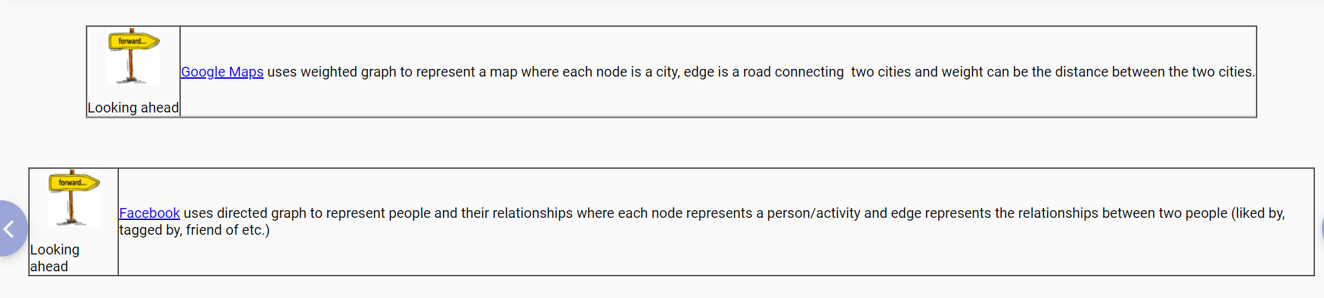

TREES-family tree structures, organization hierarchy, searching and sorting applications

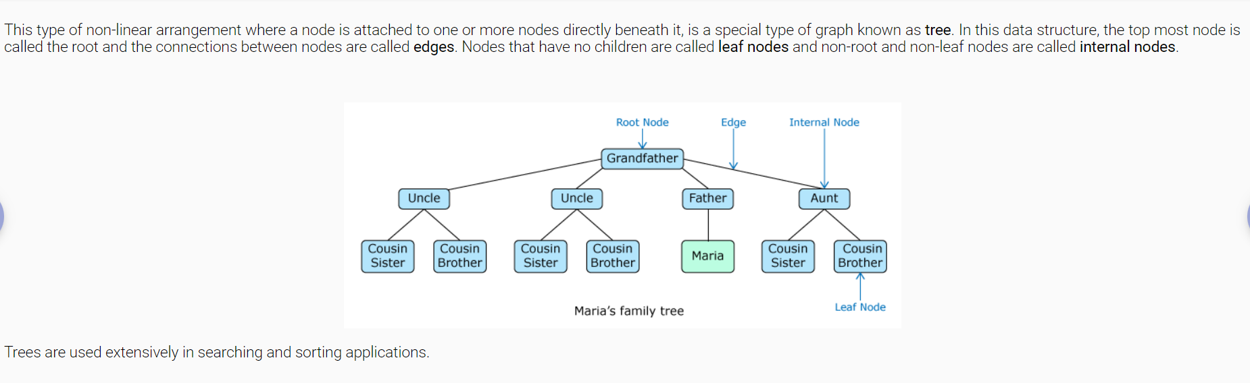

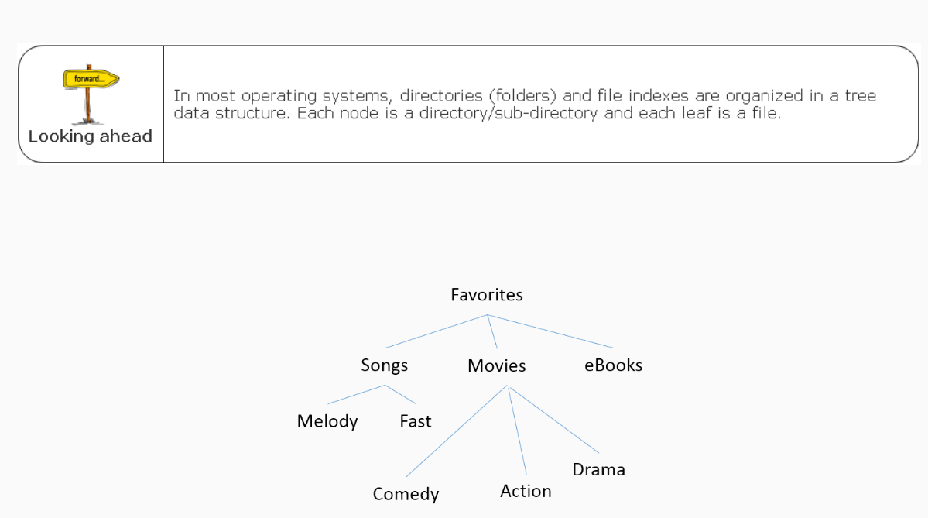

Tree is a graph without any circuits or cycles.

Balanced,Full,Complete Binary trees-check definition.